UNIT 5

SPEAKING STRATEGIES

Remember instructions for Speaking Part II “Task Cards” and speak about a company you know using idioms and phrasal verbs for your answer.

Describe a small and successful company you know.
- You should say:
- the name of the company
- how you learnt about it
- what kind of business this company does
- explain why you think this company is successful.

READING STRATEGIES

MULTIPLE CHOICE QUESTIONS

Task:
Choose the correct answer to a question or the correct ending to a sentence from 3 or 4 possible options.
Skills:
• scanning for specific information
• understanding information in the passage
Tips:
• paraphrase the information in the question and options
• locate the precise information in the passage
• answer come in order

1 Read the passage below and answer the questions.

TIDAL POWER

Undersea turbines which produce electricity from the tides are set to become an important source of renewable energy for Britain. It is still too early to predict the extent of the impact they may have, but all the signs are that they will play a significant role in the future.
A Operating on their same principle as wind turbines, the power in sea turbines comes from tidal currents which turn blades similar to ships’ propellers, but, unlike wind, the tides are predictable and the power input is constant. The technology raises the prospect of Britain becoming self-sufficient in renewable energy and drastically reducing its carbon dioxide emissions. If tide, wind and wave power are all developed, Britain would be able to close gas, coal and nuclear power plants and export renewable power to other parts of Europe. Unlike wind power, which Britain originally developed and then abandoned for 20 years allowing the Dutch to make it a major industry, undersea turbines could become a big export earner to island nations such as Japan and New Zealand.
B Tidal sites have already been identified that will produce one sixth or more of the UK’s power – and at prices competitive with modern gas turbines and undercutting those of the already ailing nuclear industry. One site alone, the Pentland Firth, between Orkney and mainland Scotland, could produce 10% of the country's electricity with banks of turbines under the sea, and another at Alderney in the Channel Islands three times the 1,200 megawatts of Britain’s largest and newest nuclear plant, Sizewell B, in Suffolk. Other sites identified include the Bristol Channel and the west coast of Scotland, particularly the channel between Campbeltown and Northen Ireland.
C Work on designs for the new turbine blades and sites are well advanced at the University of Southampton’s sustainable energy research group. The first station is expected to be installed off Lynmouth in Devon shortly to test the technology in a venture jointly founded by the department of Trade and Industry and the European Union. AbuBakr Bahaj, in charge of the Southampton research, said: ‘The prospects for energy from tidal currents are far better than from wind because the flows of water are predictable and constant. The technology for dealing with the hostile saline environment under the sea has been developed in the North Sea oil industry and much is already known about turbine blade design, because of wind power and ship propellers. There are a few technical difficulties, but I believe in the next five to ten years we will be installing commercial marine turbine farms.’ Southampton has been awarded £215,000 over three years to develop the turbines and is working with Marine Current Turbines, a subsidiary of IT power, on the Lynmouth project. EU research has now identified 106 potential sites for tidal power, 80% round the coasts of Britain. The best sites are between islands or around heavily indented coasts where there are strong tidal currents.
D A marine turbine blade needs to be only third of the size of a wind generator to produce three times as much power. The blades will be about 20 metres in diameter, so around 30 metres of water is required. Unlike wind power, there are unlikely to be environmental objections. Fish and other creatures are thought unlikely to be at risk from the relatively slow-turning blades. Each turbine will be mounted on a tower which will connect to the national power supply grid via underwater cables. The tower will stick out of the water for maintenance and to clean seaweed from the blades.
E Dr Bahaj has done most work on the Alderney site, where there are powerful currents. The single undersea turbine farm would produce far more power than needed for the Channel Islands and most would be fed into the French Grid and be re-imported into Britain via the cable under the Channel.
F One technical difficulty is cavitation, where low pressure behind a turning blade causes air bubbles. These can cause vibration and damage the blades of the turbines. Dr Bahaj said: ‘We have to test a number of blade types to avoid this happening or at least make sure it does not damage the turbines or reduce performance. Another slight concern is submerged debris floating into the blades. So far do not know how much of a problem it might be. We will have to make the turbines robust because the sea is a hostile environment, but all the signs that we can do it are good.’
______________________________________
Cambridge IELTS 9 Examination Papers from university of Cambridge ESOL examinations: English for speakers of other languages – Cambridge University Press, 2013.

2 Which section contains the following information? Match the correct letters A-F and numbers 1-4. You can use each letter more than once.

1 Location of the first proving ground
2 ways to repatriate the electricity generated on site to the UK
3 Reference to UK's previous efforts to find alternative sources of energy
4 Consider the possibility of using technology from other industries

3 Which of the following five statements about wave power did the author make? Choose five letters, A-J.

A This is a more reliable source of energy than wind energy.
B It would replace all other forms of energy in the UK.
C Its introduction was the result of public pressure.
D This will reduce air pollution.
E This could lead to the closure of many power stations in the UK.
Q It can be an instrument to increase national income.
G It may face strong opposition from other fuel industries.
H It can be sold cheaper than any other type of fuel.
I This could make up for the lack of internal areas for energy
J It is well produced near the coast with special characteristics.

4 Label the diagram below. Choose no more than two words from the text for each answer.

An Undersea Turbine
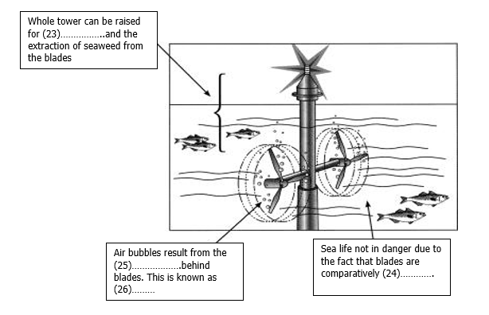
The entire tower can be raised to 1_________ and remove algae from the paddles. Air bubbles are created by 2 __________ behind the fins. That's called 3__________. Due to the fact that the leaves are relatively 4___________ there is no threat to marine life.

5 Do the following statements agree with the information given in the text?

TRUE if the statement agrees with the claims of the writer
FALSE if the statement contradicts with the claims of the writer
NOT GIVEN if it impossible to say what the writer thinks about this

1 Great Britain has been responsible for energy exports to the island states for 20 years.
2 Due to the predicted conditions, the water power is much better than wind power.
3 Cavitation and underwater debris are not a problem for the turbine blades because they are durable.
4 When several technical difficulties are eliminated, it will be necessary to update the design of the turbine blades.
5 The national power supply via grid of underwater cables is common across the country.
6 Offshore turbine farm design will not be hostile for fish and other creatures, and it will be organized in such a way to be maintained easily.
7 A powerful undersea current is a great help in tidal power.

WRITING STRATEGIES

BAR CHART

• For bar charts that present data like graphs over a period of time, use the comparing and contrasting language given there: … increased more than; there was a greater increase in ... than ...
• The survey took place in the past not the present, but you can use either the past
simple or the present simple to describe the data.
• Try to classify the items and divide them into groups rather than writing about each one in turn: the (factors) can be divided into two main groups ...
- Name the groups: ... namely those related to … and those (connected) with ...
- Compare the two groups: ... of the two, the former is the larger.
- State an important feature in this group: with ... being the most popular with 40 per cent.
• Compare and contrast the other items. Use some of the following:
- morel/less than ...
- (bigger) than .. .
- (not) as big as .. .
- twice as big/much as ...
- rather than ...
- as against/as opposed to/compared with/in comparison with ...
- in (sharp) contrast to the biggest/smallest (change) ...
- more (women) cited/achieved/participated/took part in/were involved in ... than ...
- there were more (men) than (women) who ...
• To quote from the results of the survey, you can use:
- ... percent quoted / cited/mentioned/considered ... as important
- ... was quoted/cited/mentioned/considered as the most/least important factor by ...
- ... came top/bottom/second/next, followed (closely) by ... at ... and ... respectively.
• See video to get more information: https://www.youtube.com/watch?v=E3U1Y1jgGls

The chart below shows information about changes in average house prices in five different cities between 1990 and 2002 compared with the average house prices in 1989.
Summarize the information by selecting and reporting the main features, and make comparison where relevant.
Look at the example below and complete this task. You should spend about 20 minutes on the task. Write at least 150 words.

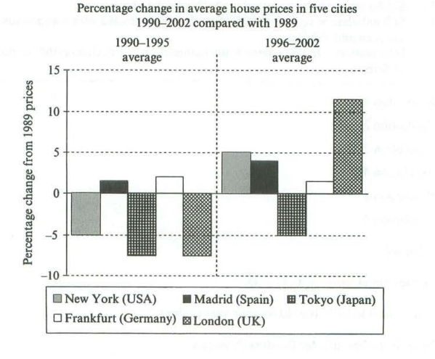

Жакипов Р. 21-МЭЛ-2П
The given bar chart depicts the average house prices in five different cities between 1990 and 2002 compared with the prices of the year 1989, a period of 12 years.
Overall, it can be seen that all of these cities showed an upward trend in the average house prices between the years 1996 and 2002, except Frankfurt.
In details, the percentage of house prices in New York in between the year 1990 -1995 was accounted just 5 percent in a negative direction. However, the same percentage in New York was on the positive side between 1996- 2002. Similarly, the average house prices in London and Tokyo (Japan) was presented in similar percentage approximately 7 percent in negative in 1990-1995 where the percentage of London peaks at the highest position at 13 percent in 1996-2002 and Tokyo city house price was still observed the on the negative side at 5 percent.
Meanwhile, the percentage change in average house price of Madrid (Spain) was only 1 percent in previous 6 years but it dramatically increased 4 times in next following year. In 1990-1995 the average house price of Frankfurt (Germany) was only 2 percent but it was interesting that it declines and reached the same percentage as Madrid (Spain) at 1 percent.
213 words, about 40 minutes.

